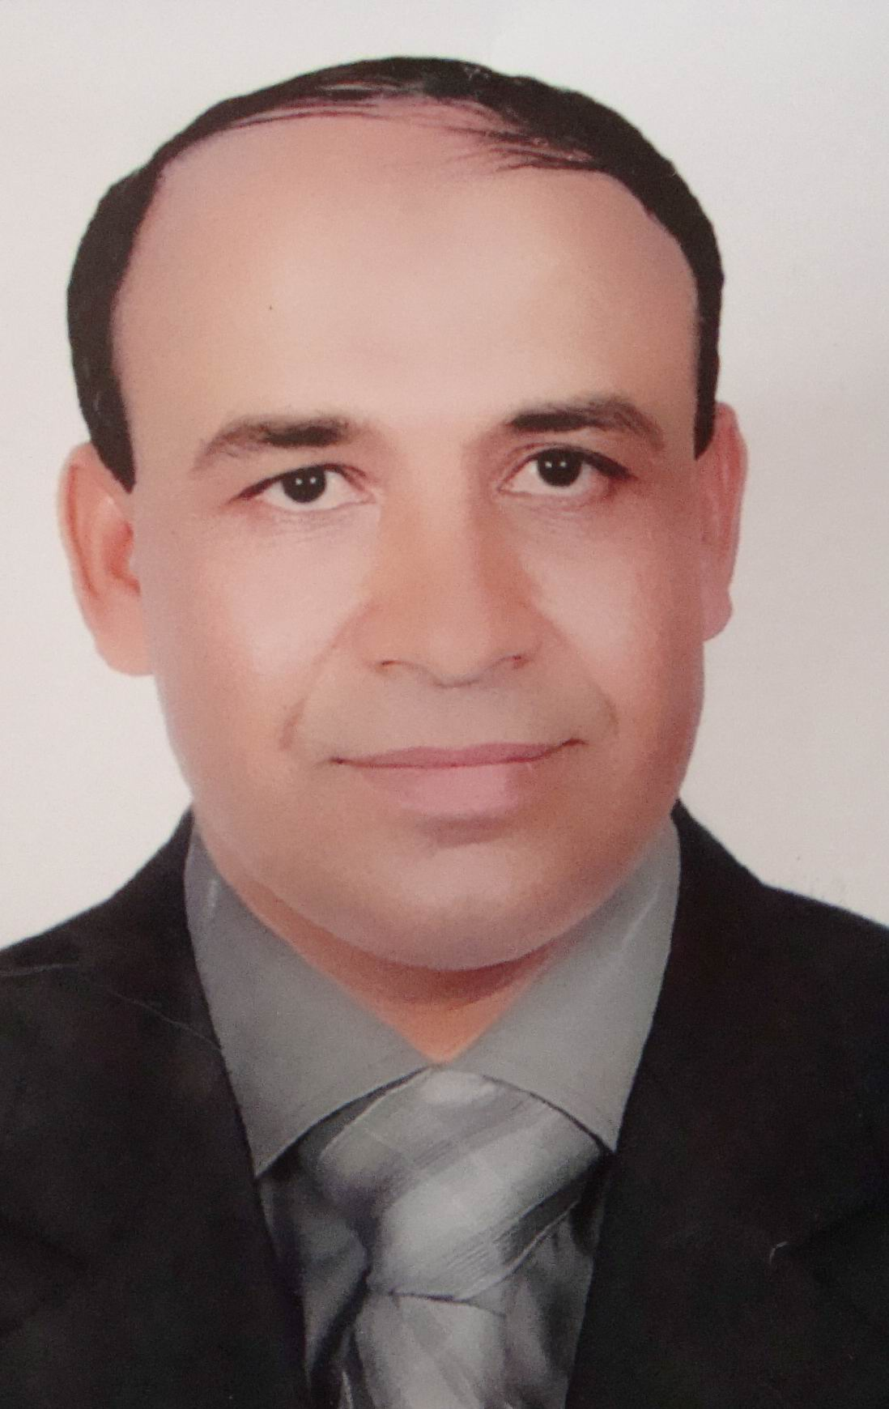
C. V.

Name: Mohammed Korany Ewies Abdel-Sadiq
Date of birth: 15/6/1969
Sex: Male
Marital state: married
Military service: done
Address: - Work: Department of General surgery, Faculty of Medicine, Assiut University, Assiut, Egypt. Post. No. 71526
I prefer mailing to be sent to my work address.
Phone No.: Home: +2088233881
+20882310866
Mobile: +201001808518
Degrees:
- M.B.B.Ch. (Faculty of Medicine, Assiut University) VERY GOOD with HONOR Sept. 1995.
- M. Sc (Medical General Surgery) Faculty of Medicine, Assiut University, EXECELLENT April 1998.
- Medical Doctorate (General surgery) Faculty of Medicine, Assiut University Dec. 2003.
Positions:
- Demonstrator of General surgery, Faculty of Medicine, Assiut University, March 1998.
- Assistant lecturer of General surgery, Faculty of Medicine, Assiut University, June 1998.
- Lecturer of General Surgery, Faculty of Medicine, Assiut University, Jan. 2003.
Research interests:
DETAILED SCOPE OF WORK 1- Operations For Portal Hypertension: -Hassab Operation. -Splenectomy, Devasculraization Of The Stomach And Oesophageal Transaction By Stippler. 2- Hepato-Biliary Surgery: -Cholecystectomy ( Open And Laparoscopic) -Hepatic Resection. -Exploration Of Common Bile Duct And Choledocho-Enteric Anastomosis. - Whipple Operation. 3- Oesophageal, Gastric And Pancreatic Surgeries: -Total Oesophagectomy And Gastric Pull-Up. -Hiller’s Operation (Open And Laparoscopic). -Nissen Fundo-Plication (Open And Laparoscopic). -Gastrectomy. -Truncal Vagotomy And Drainage (Open And Laparoscopic). -High Selective Vagotomy (Open And Laparoscopic). -Subtotal And Total Pancreatectomy. 4-Small And Large Bowel Surgeries: -Resection And Anastomosis For Small Bowel Lesions. -Colectomy.
-Abdomino-Perineal Operation. -All Anal Operations. 5- Hernia Operations (Open And Laparoscopic). 6--Varicocelectomy (Open And Laparoscopic). 7-Mastectomy (All Types). 8-Cervical Sympathectomy (Laparoscopic). 9-Neck Surgeries : -Thyroidectomy -Block Neck Dissection. -Parathyroidectomy. 10-Bariatric Surgeries: -Scopinaro Operation. -Modified Scopinaro (Bpd + Duodenal Switch). -Gastric Bypass. -Vertical Banded Gastroplasty. -Balloon Gastroplasty. -Sleeve Gastrectomy. (Open and Laparoscopic) 11- Limb Surgeries : -Amputations. -Varicose Vein Operations. -Excicion Of Tumors 12-Emergency Operations. 13-Diagnostic Laparoscopy.
TEACHING EXPERIENCE
• 9 Years’ Experience in Teaching Medical Students in Assiut University.
• 9 Years’ Experience in Teaching Nursing Students (Surgical Course) In Assiut University Hospitals.
• Teaching Operative Procedures for Residents, Senior Residents and Assistant Lecturers in Assiut University Hospitals. • Supervising many master and M.D. Thesis.

Professional Member ship
- Member of the Egyptian Medical syndicate
- Member of the Egyptian society of surgeons

